**URBAN CORE INFRASTRUCTURE & RURBAN CLUSTER**

**Urban Core Infrastructure:**

* The total area of Mysore district is 6307 sq. km.
* Mysore district with a total population of 30, 01,127 stands at 3rd place in the State.
* The district has the second highest density of 476 in the State.
* Mysore district accounts for 4.9 percent of the total population of the State, third highest after Bangalore and Belgaum.
* With the decadal growth rate of 13.6 percent, it ranks 11th in the State in terms of decadal growth rate

**Regional Planning and City Planning:**

* City planning focuses on the land use plans, spatial growth and policies which are at local level (affecting that particular city or town)
* Whereas in case of regional planning the emphasis on the policies is more.
* Those policies become the guidelines for the urban areas and their existing plans are modified accordingly.
* Regional planning is an urban planning strategy that focuses on the social, economic, and environmental development of a specific area.
* Regional plans address the needs of the entire region rather than just one municipality.
* The benefits of regional planning include coordination of transportation, housing, and other public services such as police, fire departments, hospitals, and schools.

**Urban Core Infrastructure Includes:**

* Adequate water supply
* Assured electricity supply
* Sanitation, including solid waste management
* Efficient urban mobility and public transport
* Affordable housing especially for the poor
* Robust IT connectivity and digitalization

**Urban Core Infrastructure**

**Demographic Studies (As per 2011 Census & Present 2024 Population):**

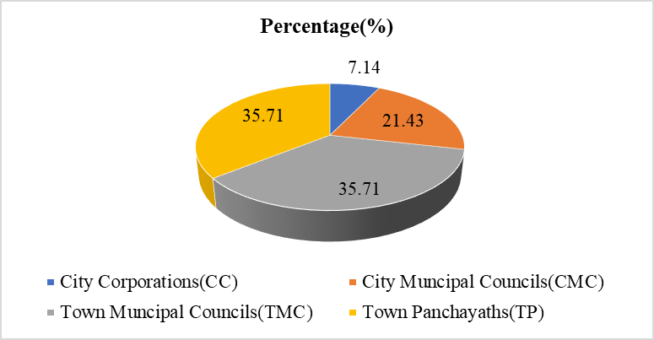







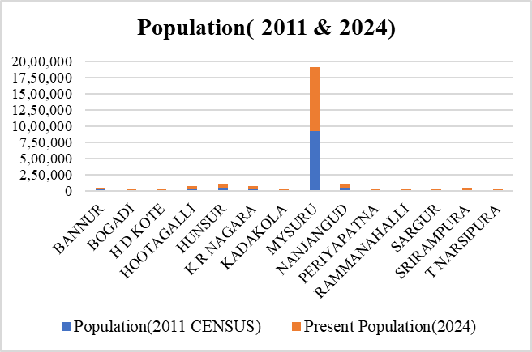

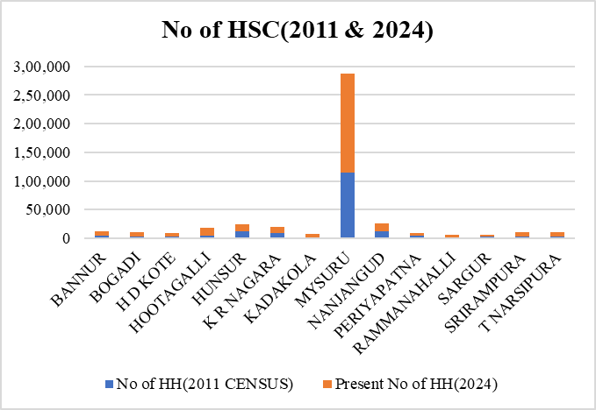



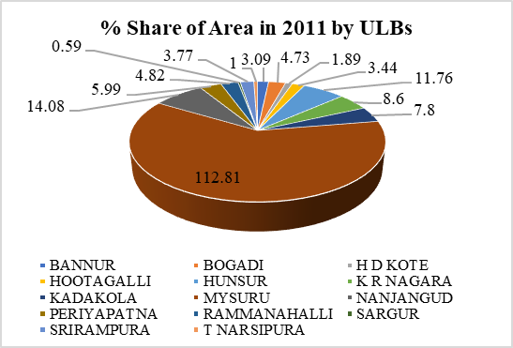

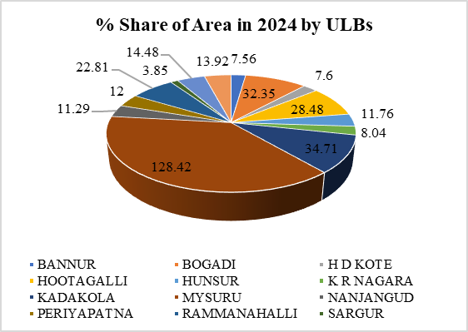



**Demographic Studies for 2041 (Projected Population):**

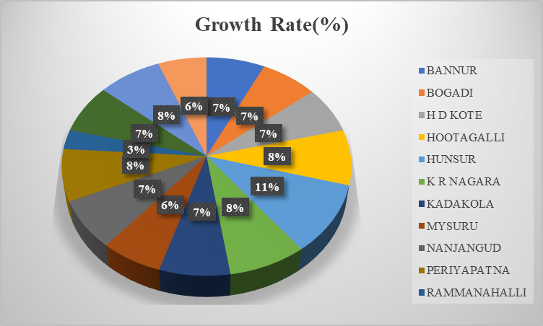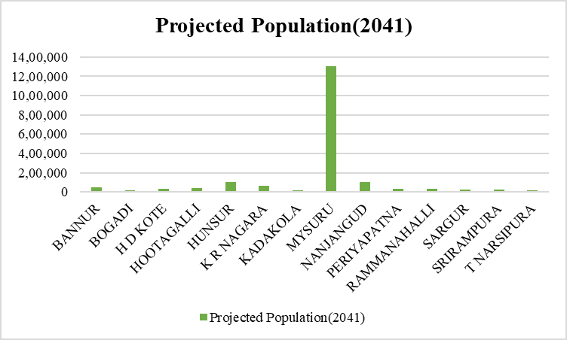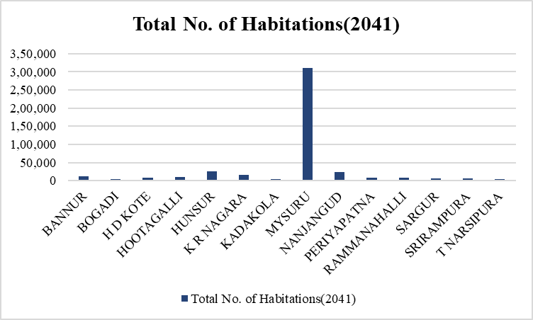





**1.Transportation:**

**(a) Analysis:**



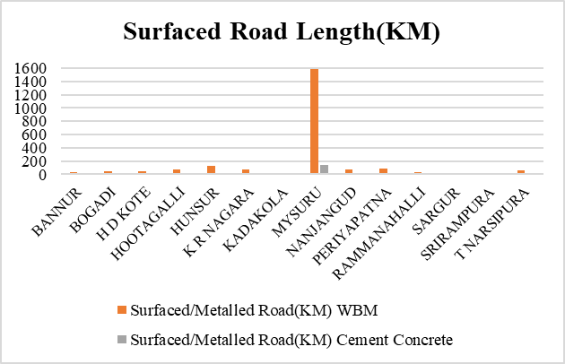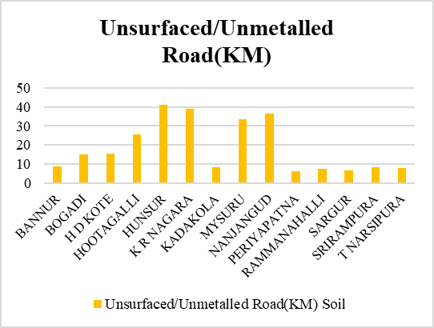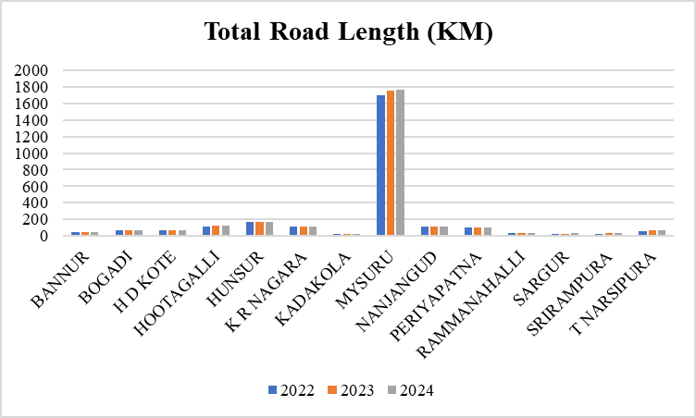

**National Highways (NH):**

1. NH 275: Connects Bangalore to Mangalore
2. NH 766: Connects Mysore to Kollegal and beyond.
3. NH 150A: Connects Mysore to Chamarajanagar.

**State Highways (SH):**

1. SH 17: Connects Bangalore to Mysore via Ramanagara.
2. SH 88: Connects Mysore to Nanjangud.
3. SH 12: Connects Mysore to Madikeri
4. SH 90: Connects Hunsur to Periyapatna
5. SH 33: Connects Kollegal and Bannur
6. SH 79: Conects T Narsipur to Bannur
7. SH 86: Connects T Narsipur and Kollegal
8. SH 85: Connects Mysore,Hassan and Holenarsipura
9. SH 81: Connects Nanjungud to Chamrajnagar

**Conclusion:** The dynamics of urban development has resulted in a lot of mixed use getting developed along major roads, esp. the NH and the core city area

**Railways:**

* Railways also play a major role in connectivity.
* There are 16 Railways Station
* Mysore Railway Station is the main Station

**(b) Proposals:**



**Atal Mission for Rejuvenation and Urban Transformation -AMRUT:**

* To provide basic civic amenities like water supply, sewerage, urban transport, parks as to improve the quality of life for all especially the poor and the disadvantaged.
* The focus of the Mission is on infrastructure creation that has a direct link to provision of better services to the citizens

**2. Solid Waste Management:**

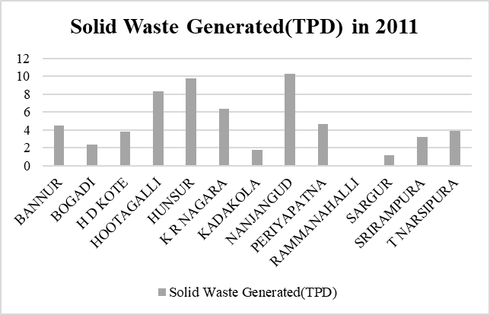**(a) Analysis:**

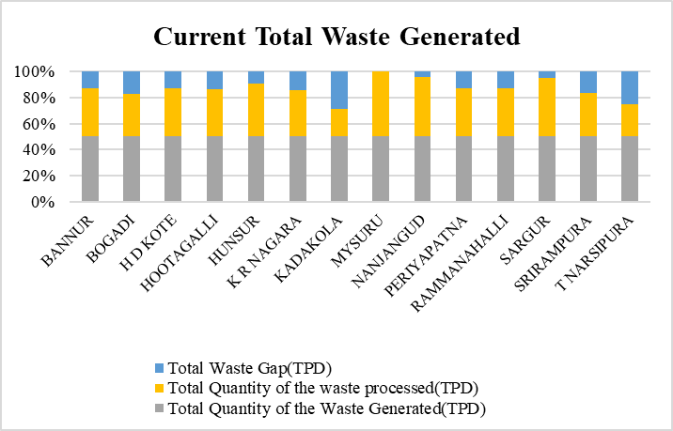





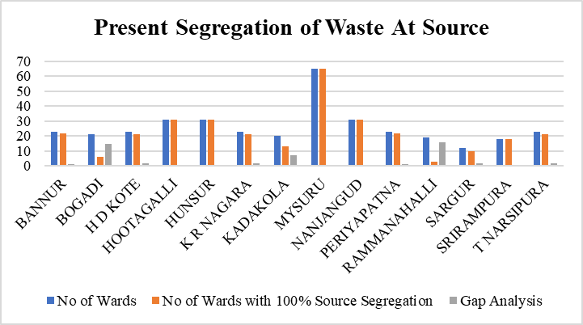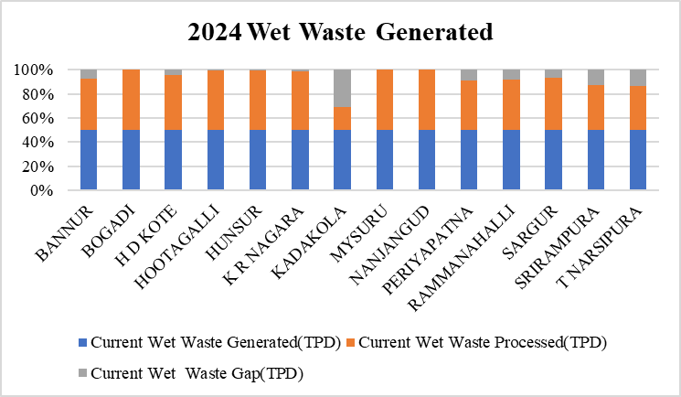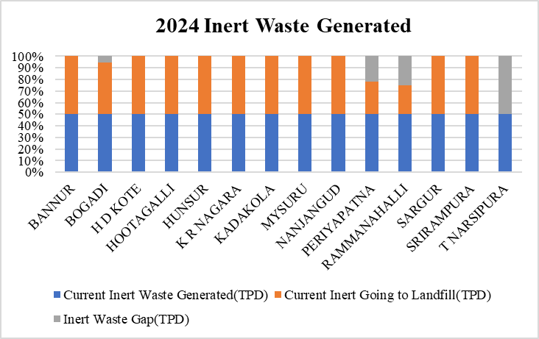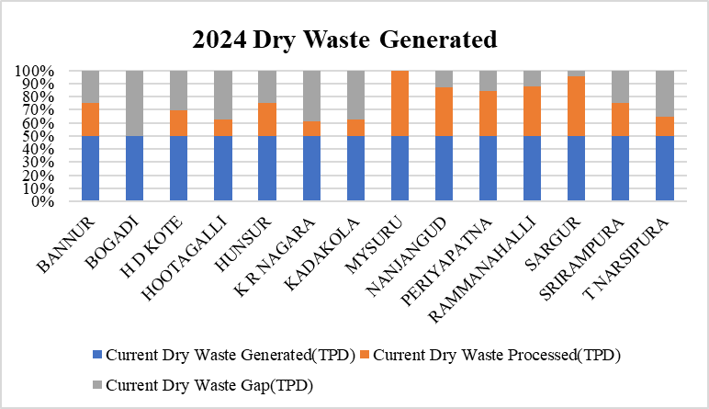





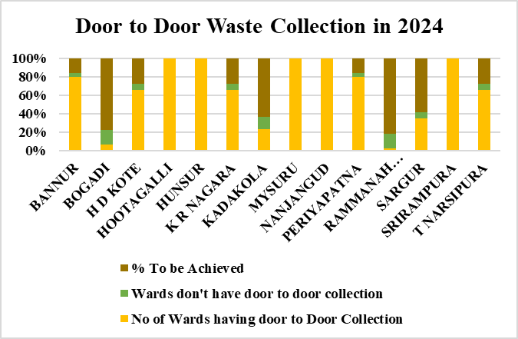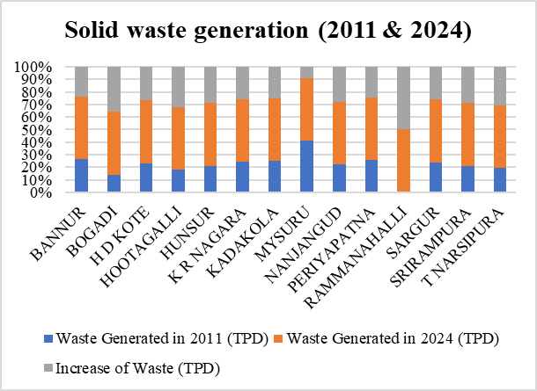



* Mechanical road sweeping is not carried out in the district only manual sweeping is practiced.
* All ULB's have dedicated vehicles for Waste collection
* All ULB's have SWM site in the District but it’s not in function in Bogadi , Kadakola ,Ramanahalli, Hootagalli & Srirampura
* Transportation of the waste to the processing site is within 10 Km from the towns
* Due to non-functioning of SWM site in Bogadi, Kadakola, Ramanahalli, Hootagalli & Srirampura, collected waste is sent to Mysore SWM site for scientific disposal.

**(b) Proposals:**





**Procedure followed for MSW disposal in Mysore:**

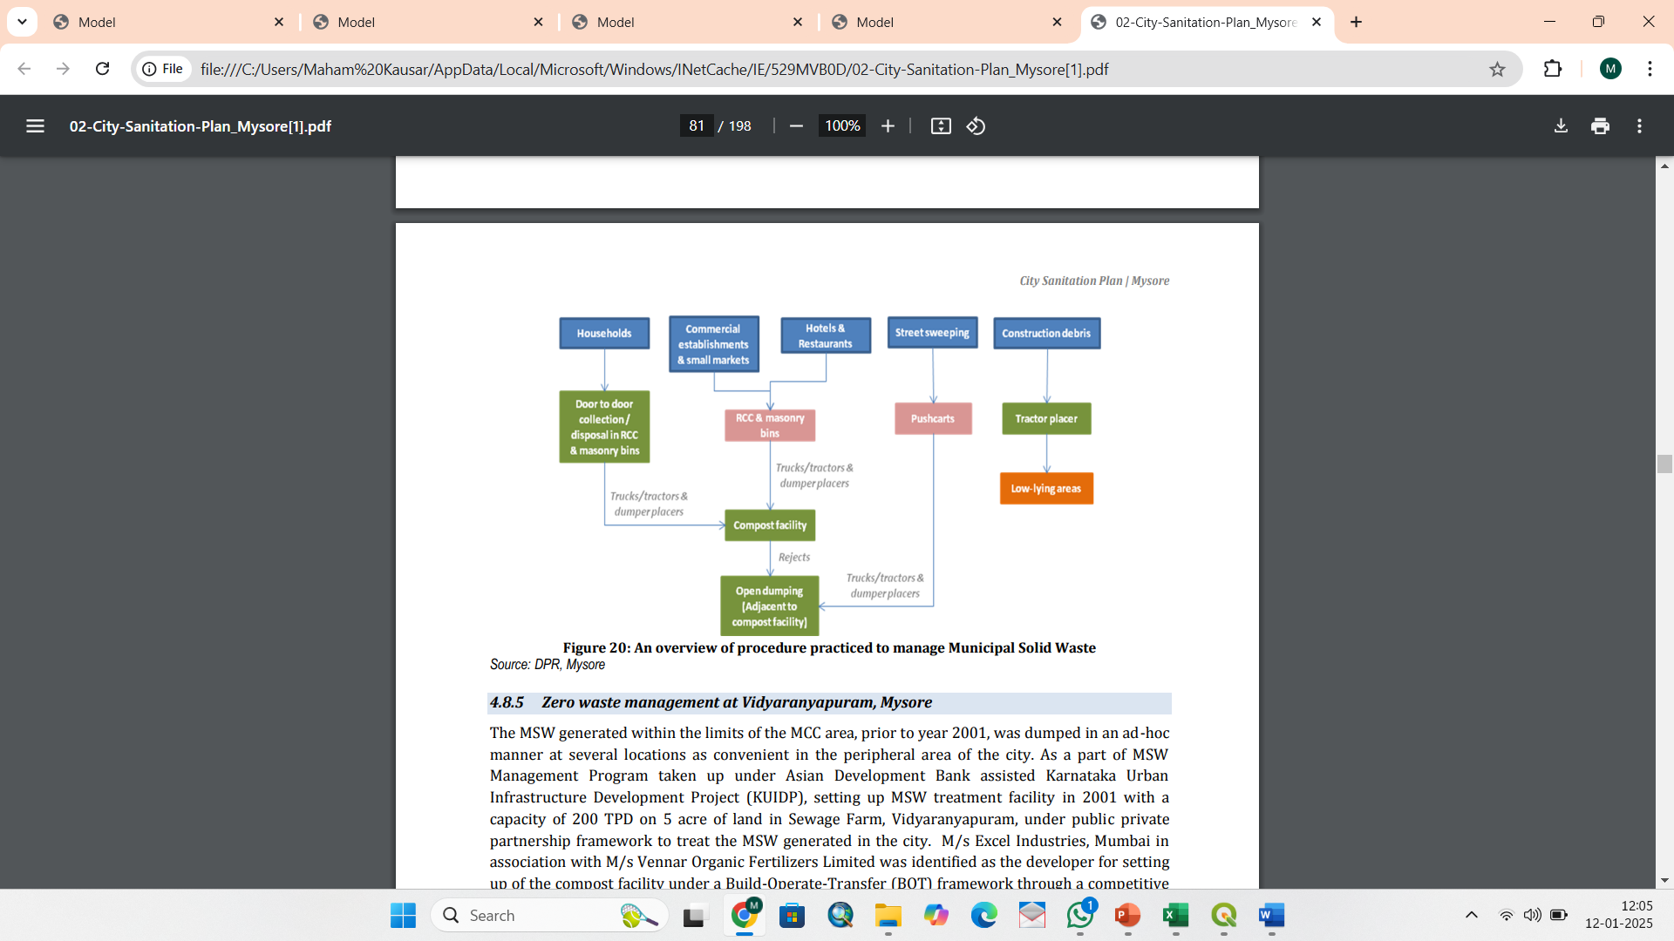



**Swachh Bharat Mission:**

The objectives of the mission are mentioned below:

* All households and premises segregate their waste into Wet Waste (from kitchen and gardens) and Dry Waste (including paper, glass, plastic, and domestic hazardous waste and sanitary waste wrapped separately).
* 100% door to door collection of segregated waste from each household/ premise.
* 100% scientific management of all fractions of waste, including safe disposal in scientific landfills.
* All legacy dumpsites remediated and converted into green zone.
* All used water including fecal sludge, especially in smaller cities are safely contained, transported, processed and disposed so that no untreated fecal sludge and used water pollutes the ground or water bodies.

**3.Sewage Treatment Plant:**

**(a) Analysis:**

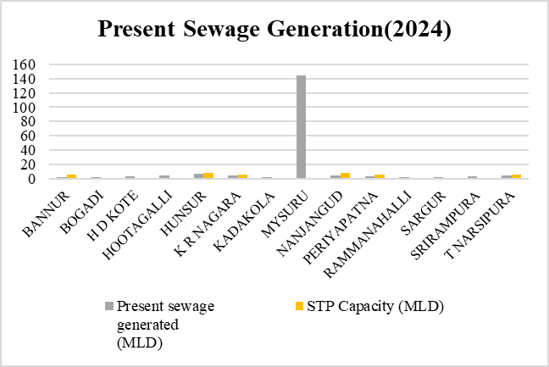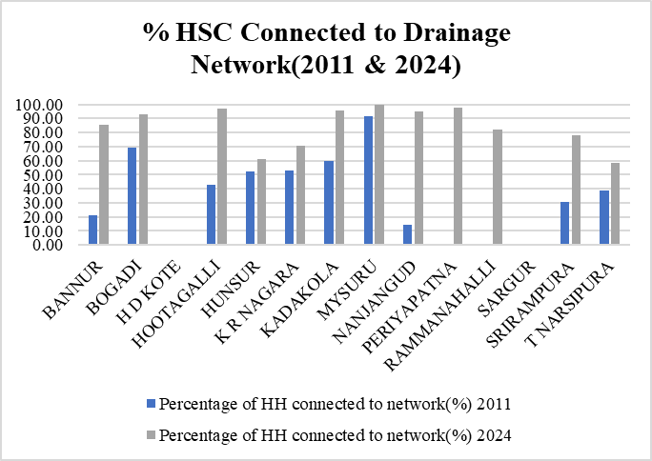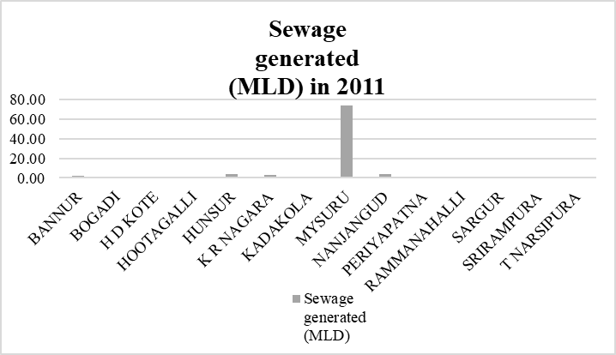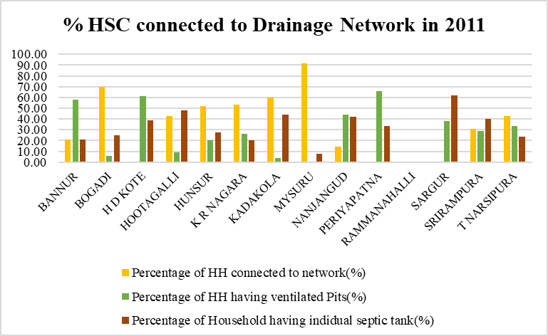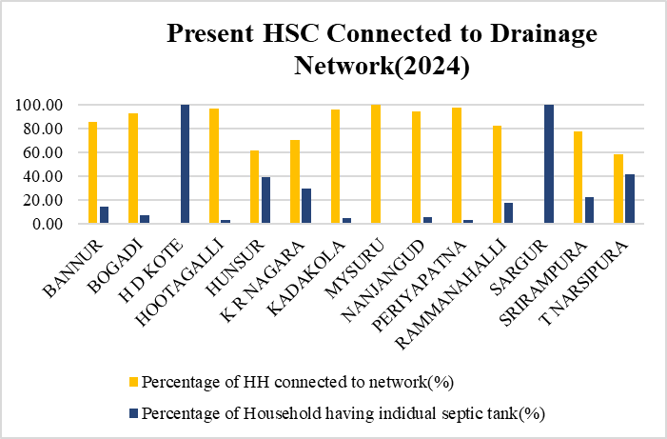



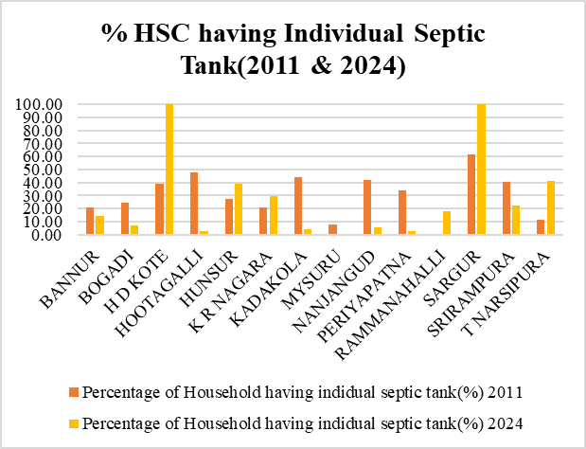





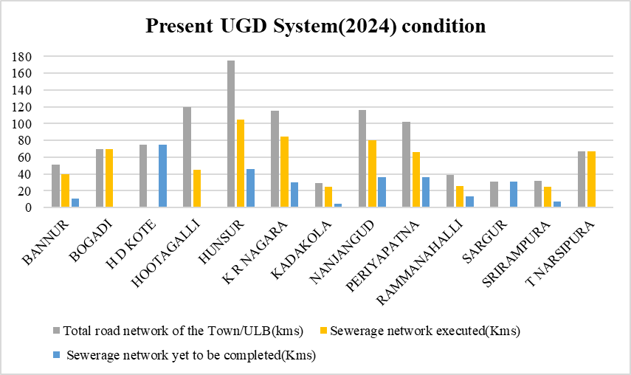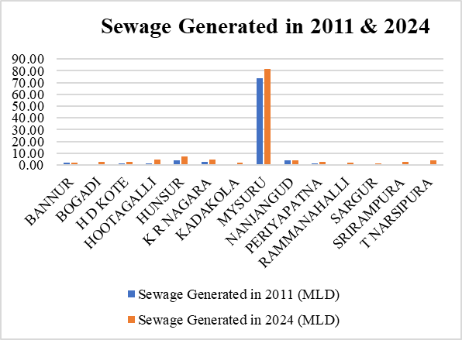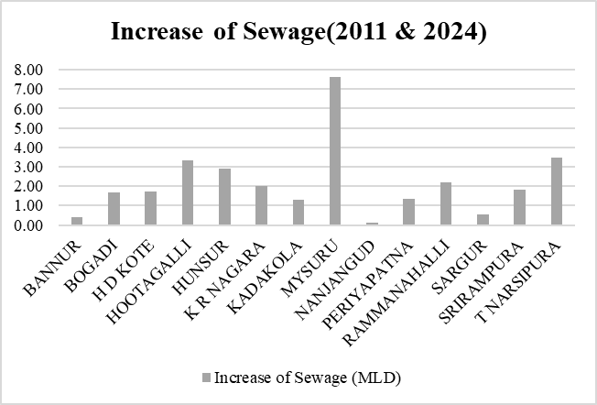





* There is no working underground drainage system in H D Kote & Sargur
* The system of soak pits and septic tanks are used for the disposal of sewage in the city.
* In H D Kote, the sewage from the city is collected through open drains, Septic Tanks and let into Nalas which is eventually joining Kabini River
* In Sargur, the sewage from the city is collected through open drains, Septic Tanks and let into Nalas which is eventually joining Nagu River Downstream.
* Bogadi,Srirampura,Kadakola,Ramanahalli,Hootagalli doesn’t have STP hence the Sewage is treated by Mysore’s 3 STPs

**(b) Proposals:**









**SBR Reactor:**

The Sequencing Batch Reactor is a type of activated sludge process for wastewater treatment where the processes occur in a single tank in sequential steps.

How It Works:

SBR operates in cycles, with each cycle consisting of five stages:

1.Fill: Wastewater enters the reactor.

2.React (Aeration): Air is supplied to promote microbial activity that breaks down organic matter.

3.Settle: Aeration stops, and solids settle at the bottom of the tank.

4.Decant: The treated water (supernatant) is removed. 5.Idle: The reactor prepares for the next cycle.

Applications:

SBR is used for municipal and industrial wastewater treatment, particularly where flow rates or loadings vary.

**4.Water Supply:**

**(a) Analysis:**

* River Kaveri is the main source of drinking water supply.
* Almost all the towns depend directly on river (direct pumping, infiltration galleries, shallow wells in the river bed etc) during low flow season, the water supply is supplemented by groundwater.
* The Kaveri water quality is classified as Category “C” Drinking water source after conventional treatment and disinfection in the upstream of town where the intake is situated.
* However, in the down steam, due to discharges from various industries and sewage from different areas of Mysore, the water quality on the downstream side is poor.







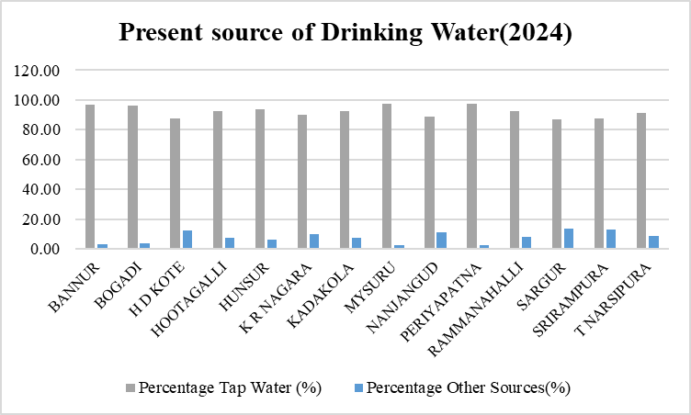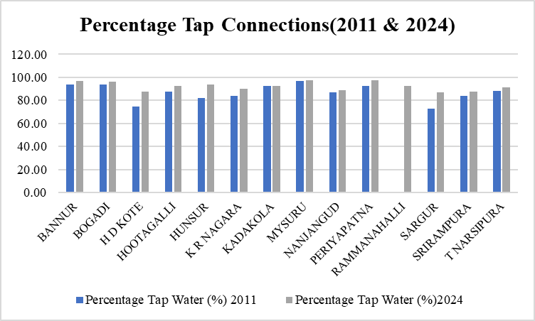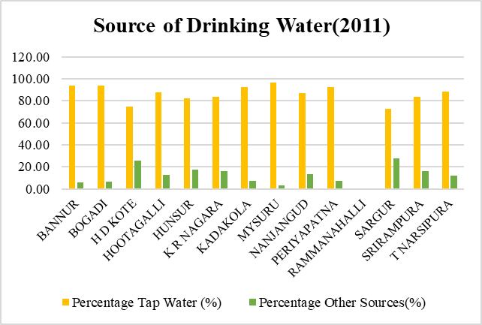





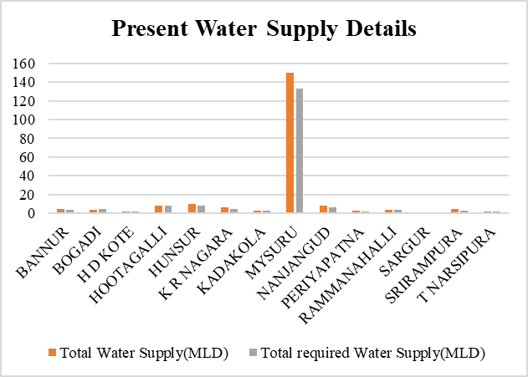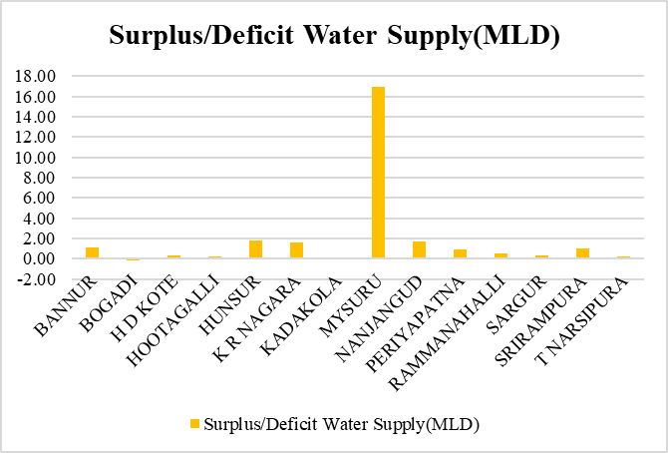



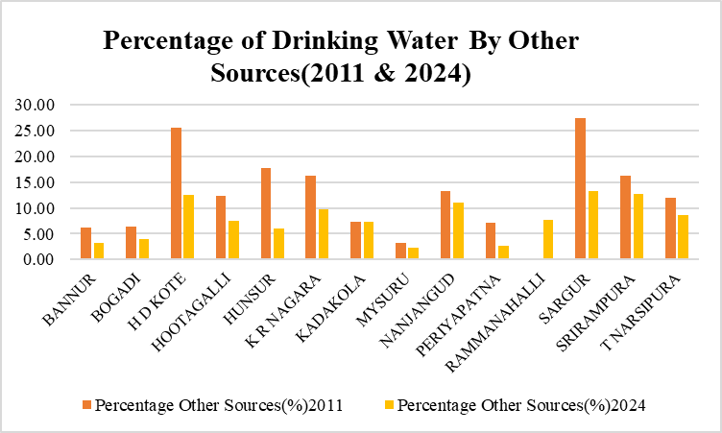

**Water Supply Schemes:**

**1.Jaladhare Program:** To provide surface water-based drinking solutions.

* Multi-village water supply schemes (MVS) sourcing water from rivers and reservoirs, like the Kaveri River, treating it, and delivering it to multiple villages.
* SVS (Single Village Scheme): Designed for villages with sufficient local water resources. Provides piped water supply to individual households within a single village.

**2.Urban Water Treatment Plants:**

* Mysore city has water treatment plants at Belagola, Melapura, and Hongalli that manage raw water from the Kaveri River.
* These plants ensure treated water meets safety standards for drinking, even amidst seasonal variations in water quality

**3.Jal Jeevan Mission:**

* Integrated with rural areas, this mission aims for 100% household tap connections, prioritizing safe and piped water for drinking.

**(b) Proposals:**











**Rain Water Harvesting:**

* Due to Climate Change, there will be severe impact in the water supply in the future, as it dependent on the Rainfall hence we need to collect the rain water.
* The Rainwater Harvesting System should be introduced in addition to the Water Supply Schemes in the ULBs
* By implement the Rainwater Harvesting System mandatorily for HHIG, HIG & MIG Houses we can to some extent reduce the reliance on water supply by the Corporation

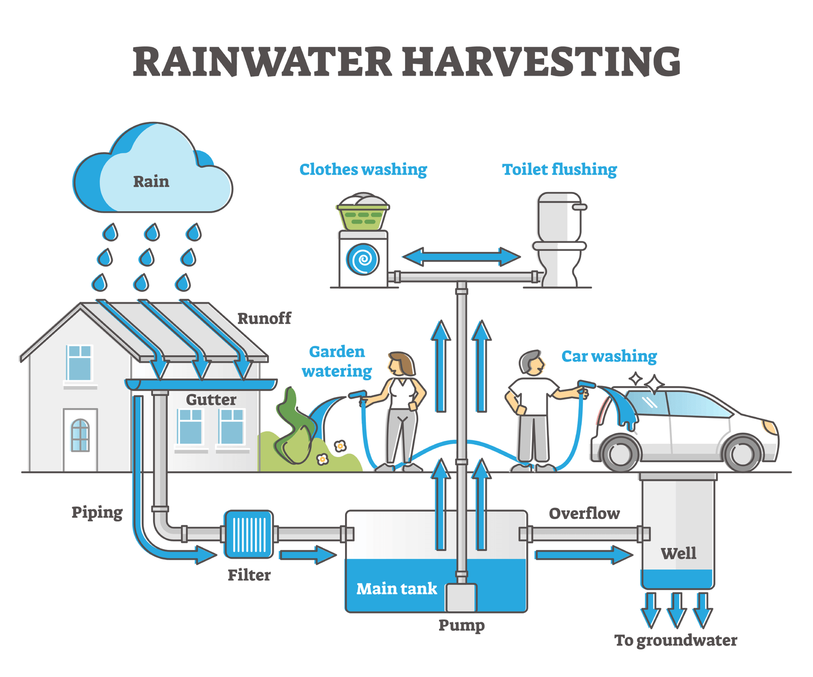

**5.Street Lights:**

**(a) Analysis:**



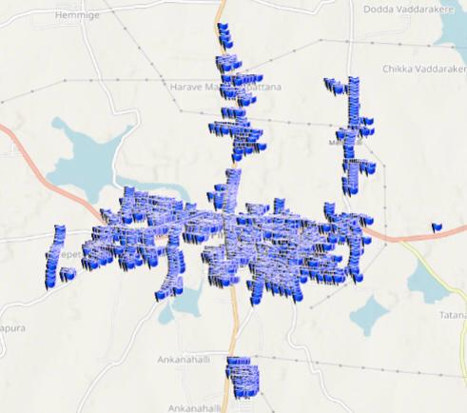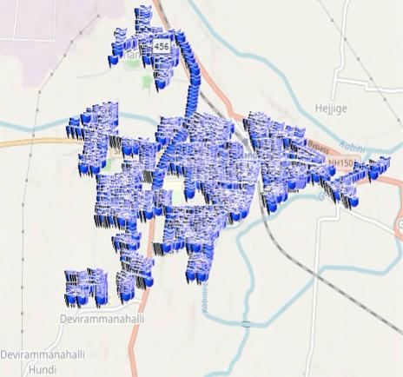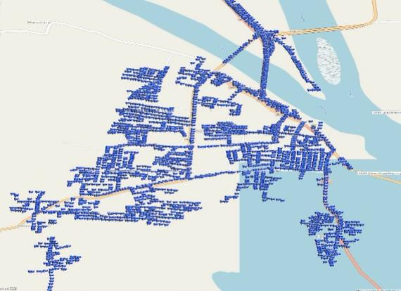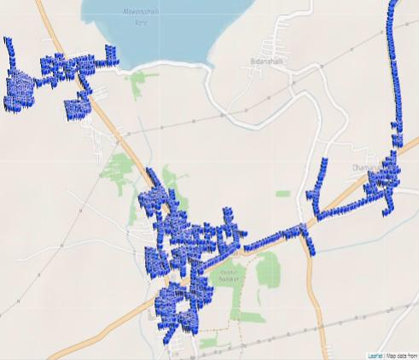

**Present Street Light Location using GIS**

**T N Pura Bannur**

**Periyapatna Nanjangud**

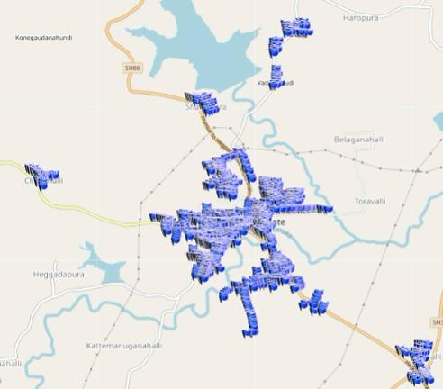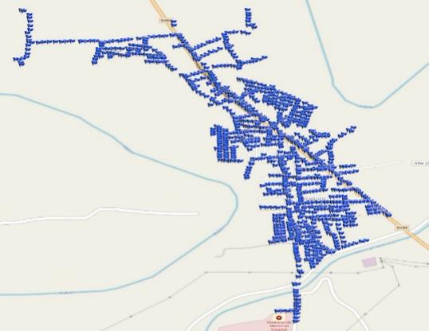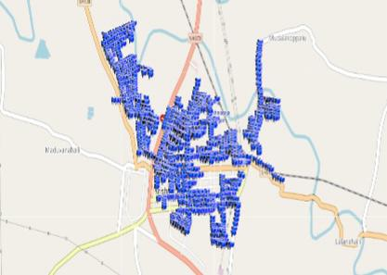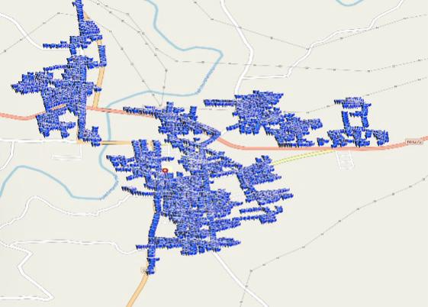

**Hunsur K R Nagara Sargur H D Kote**

* Electricity Consumption in all the ULBs is 43.11 MU for the Street Lights.
* 30.68 Crores is the energy Cost of all the ULBs for the Street Lights**.**

**Existing Infrastructure Deficiencies:**



**(b) Proposals: **



**Smart Street Lighting System:**

A smart street lighting system is an advanced, automated lighting solution designed to improve the efficiency, functionality, and sustainability of traditional street lighting.

Key Features of a Smart Street Lighting System

1.Energy Efficiency: Utilizes energy-efficient LEDs and intelligent control to minimize electricity consumption.

2.Automation: Automatically adjusts brightness based on factors like traffic, motion, or ambient light.

3.Remote Monitoring and Control: Allows city operators to manage lights remotely through a centralized dashboard.

4.Real-Time Data Collection: Equipped with sensors to monitor light levels, weather conditions, and maintenance needs.

5.Adaptive Lighting: Lights can dim during low-traffic hours or brighten in areas with high activity.

6.Integration with Smart City Systems: Can be linked to systems like traffic management, surveillance, and environmental monitoring.

**RURBAN CLUSTER**

A ‘Rurban cluster’ is a cluster of geographically contiguous villages with a population of about 25000 to 50000 in plain and coastal areas and with a population of 5000 to 15000 in desert, hilly or tribal areas.

**Vision:** Development of a cluster of villages that preserve and nurture the essence of rural community life with focus on equity and inclusiveness without compromising with the facilities perceived to be essentially urban in nature, thus creating a cluster of Rurban Villages

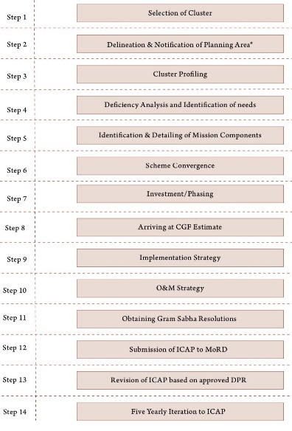**Preparation of Integrated Cluster Action Plan:**

**STEP 1: Selection of Cluster:**

* The cluster selection process is done by the Ministry and the State RD Departments.
* The Ministry identifies a set of potential locations (sub districts) for Rurban clusters.
* The State identified a set of contiguous villages around a growth centre within the sub district to form a Rurban cluster.

**The selection of sub districts by the Ministry: By considering various parameters:**

1. Decadal Growth in Rural Population. :35%
2. Decadal Growth in Non-Farm work participation :35%
3. Presence of Economic Clusters :10%
4. Presence of places of Tourism and Religious significance :10%
5. Proximity to Transport Corridors :10%

**The State Governments selects the clusters: By considering the following parameters**:

1. Decadal growth in Rural Population.
2. Rise in Land Values.
3. Decadal growth in Non- Farm Work force participation.
4. Percentage Enrollment of girls in secondary schools.



**STEP 2: Delineation of Planning Area:**

**1.Delineation of Planning Area:**

* The cluster boundary needs to be clearly delineated following the process specified in the respective State/UT statutes.
* The Planning area needs to be distinctively shown on the map with GIS co-ordinates on a scale of 1:8000
* Planning areas shall as far as possible include full plot Nos ( Survey Nos).
* Two or more clusters may be combined into one Planning Area in consultation with the Planning Authorities in the State

**2.Notification of Planning Area:**

* The declaration of the planning area shall be widely published in at least 2 local news-papers having wide circulation as well as by a public notice affixed at prominent places, Government offices, local authorities and public places situated within the Planning Arca.
* ****This will be followed by initiation of the Spatial Planning Component of the ICAP. The process shall follow the planning norms as laid down in the State Town and Country Planning Acts



**STEP 3: Cluster Profiling:**

The existing profile of the cluster needs to be detailed out at 2 levels

1. General Profile
2. Component Profiling

**(1) General Profile:**

Under the General Profiling the Demographic details of the GPs within the cluster, the socio-economic profiling, cultural profiling and the administrative profiling of the GPs need to be done.

1. **Demography:**

This will enable planning and designing as per the demographic needs and trends for each of the components chosen for the cluster

**b. Socio Economic& Cultural:**

This will enable identification of the most appropriate needs for the cluster as well as understand the latent potential of the cluster, which can be further developed or given impetus under this Mission.

**c. Administrative:**

It is important to understand the administrative profile of the cluster for smooth implementation of the Mission and to enable setting up of the institutional frameworks at the block and cluster level.

**(2) Component Profiling:**

****14 desirable components have been listed out as ideal components for the cluster, however giving flexibility to the States to decide other relevant components required to develop the cluster.









**(2) Component Profiling:**



**STEP 4: SWOT Analysis & Vision:**



**Vision:**

The cluster is proposed to be an agrarian cluster which will promote Allied activities and Agro based industries within the cluster to increase the productivity, income and employment in the sector, also focusing on upgrading the existing basic amenities as per the Standards

**STEP 5: Deficiency Analysis & Identification of Needs:**

The assessment will aim at understanding the reasons for the growth in the economy of the region, identify the key economic growth drivers, assess the basic strengths of the cluster and identify the opportunities for economic growth of the cluster.







**STEP 6: Prioritization of Needs:**









**STEP 7: Proposals:**



